Department of Electrical Engineering
University of Moratuwa

EE-3024 : Project
Advanced Light Intensity Indicator (ALII) Module

Group Members
230442L – Nimadith W.N.A.C.
230445A – Niroshan I.A.K.A.
230446D – Nirukthi G.L.P.
230459U – Palliyaguru D.R.
230460N – Pamod B.G.A.Y.

Introduction
The Advanced Light Intensity Indicator (ALII) module is designed to measure, stabilize, and display ambient light levels using a fully hardware-based architecture. As modern cities move toward smarter and more energy-efficient lighting systems, reliable light-sensing modules have become essential. The ALII module contributes directly to this goal by providing real-time light intensity information, enabling the optimization of artificial lighting and promoting energy conservation in both indoor and outdoor environments.
This module not only indicates instantaneous light intensity but also incorporates features to ensure accuracy, stability, and long-term monitoring. An analog filtering stage removes electrical noise commonly present in lighting systems, improving the reliability of the LDR signal. Sudden fluctuations are avoided by allowing the user to enable a stabilization feature, ensuring that the display updates only when the light level remains steady for a defined period. In addition, a secondary system calculates and displays the average light intensity over an extended duration, offering deeper insight into lighting conditions.
The ALII module is fully implemented using basic electronic components, such as gate ICs, flip-flops, comparators, and RC timing networks. No programmable devices or pre-built functional ICs are used, ensuring that the system remains both educational and technically transparent. Through these design principles, the ALII module demonstrates a practical, robust, and energy-aware approach to ambient light monitoring.

Task 1: Analog Filtering

Objective
To eliminate unwanted 50–100 Hz electrical interference from the LDR signal and provide a clean, stable input for the digital light-level processing stage.

Background
The LDR is powered from a DC supply, but the surrounding environment; especially fluorescent lamps, LED drivers, and AC mains wiring introduces noise into the sensor output.
Common disturbances include:
- 50 Hz mains ripple
- 100 Hz flicker from rectified lighting circuits
- Switching noise from drivers
- Rapid voltage fluctuations during artificial light flicker
If these noise components are not removed, the system will produce unstable readings, causing the 7-segment display to jump intermittently.

Filtering Approach
A Sallen Key low pass filter is used to smooth the LDR voltage before it reaches the comparator bank.
This choice is ideal for the ALII module because:
- It removes 50–100 Hz noise effectively
- It allows slow-changing natural light variations to pass
- It is stable, low-cost, and easy to integrate
Component selection:
- R = 18 kΩ
- C = 1 µF
Cut-off frequency design:
$$f_{c}=\frac{1}{2πRC}$$
$$f_{c}=\frac{1}{2π(18×{10}^{3})(1×{10}^{-6})}$$
$$f_{c}=8.84 Hz$$
We get the cut-off frequency as 9 Hz approximately. So cut-off frequency is significantly lower than the 50 Hz main noise. This second-order filter provides strong attenuation at this frequency, ensuring that the comparators receive a clean and noise-free voltage signal.

Circuit Implementation
The LDR forms a voltage divider with a fixed resistor. RC filter capacitor is connected from the divider output to ground. The filtered voltage is fed into an op-amp comparator, which produces a clean digital level for the logic circuitry.
This arrangement ensures that the comparator is always driven by a smooth and noise-free signal, preventing false transitions.
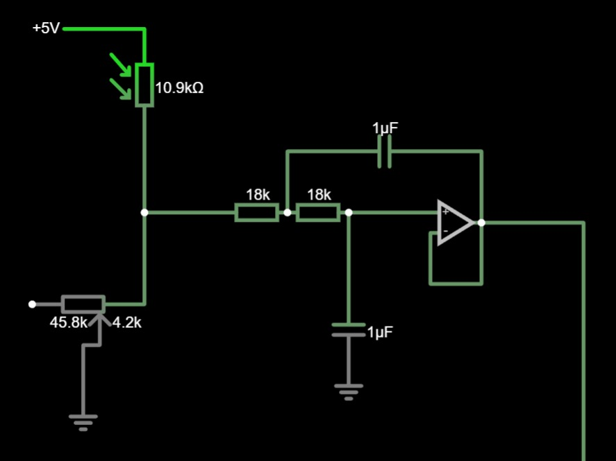

- 50 Hz

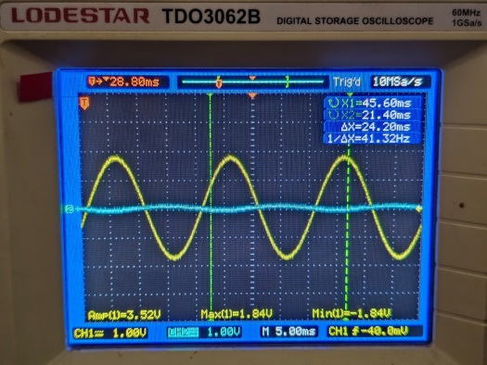
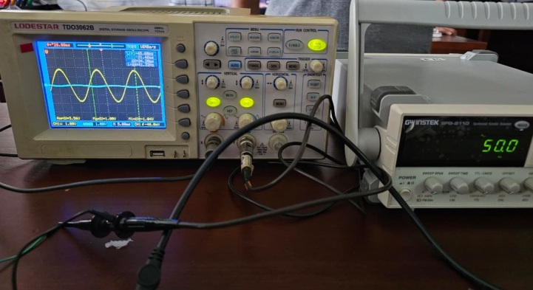

- 100 Hz 10 Hz

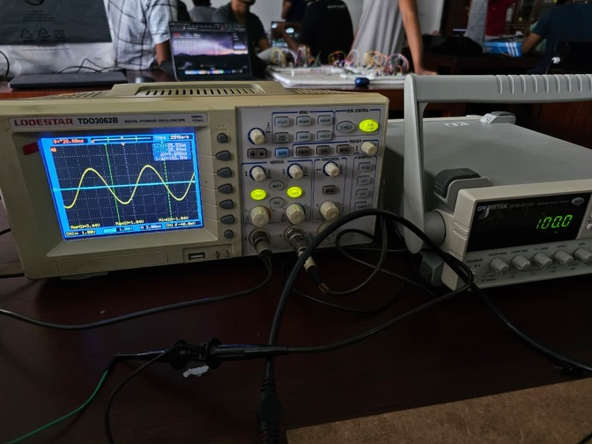
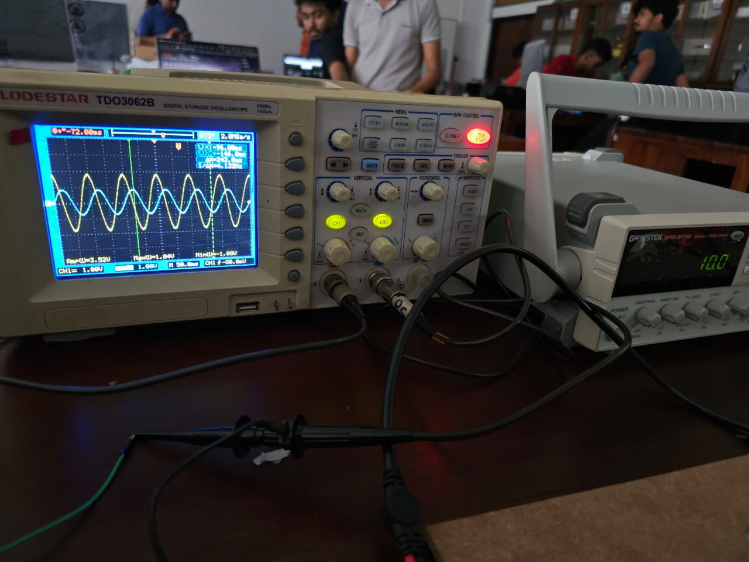

Summary
The analog filtering stage plays a crucial role in stabilizing the ALII system. By removing mains-related interference and flicker noise, it ensures that:
- The digital logic receives a clean and reliable signal
- Display readings remain steady
- Only genuine ambient light variations affect the system
This improves the overall accuracy and reliability of the ALII module.

Task 2 – Light Level Detection and Display

Objective
To measure ambient light using an LDR and display the corresponding brightness level from 0 (dark) to 6 (maximum light) on a 7-segment display, using only analog components and logic gates as required by the project constraints.

Overview
The Light Intensity Indication system converts changes in light into a 3-bit digital value, which is then decoded and shown as a number (0–6) on a 7-segment display.
The design avoids programmable ICs and instead uses comparators, resistor reference levels, and logic gates to perform the conversion.

Working Principle
- LDR Response to Light
  - Resistance decreases when light increases.
  - This change is converted into a voltage using a voltage divider.
- Analog Voltage Levels
  - The filtered LDR output (from Task 1) provides a stable analog voltage proportional to brightness.
- Comparator Ladder (Threshold Detection)
  - A series of reference voltages divides the range into 8 light levels.
  - Each comparator checks whether the LDR voltage is above its threshold.
  - The output pattern uniquely represents the current light level.
- Binary Encoding (3-Bit Output)
  - Comparator outputs are combined using logic to generate a 3-bit binary number: 000 to 111
- Binary 7-Segment Decoder
  - A custom decoder built using AND, OR, and NOT gates.
  - No decoder ICs (e.g., 7447) are used, ensuring compliance with project rules.
  - Output lines activate the correct segments (a–g) to display the digits 0–7.

Circuit Implementation

1. Voltage Divider + Filtered LDR Output
- LDR + fixed resistor form voltage divider.
- Capacitor smooths the signal.

2. Comparator Ladder
- Seven reference voltages created using a resistor chain.
- Each comparator outputs “1” when LDR voltage crosses its threshold.

3. Priority + Binary Logic
- Threshold outputs are combined to form a clean 3-bit binary level.

4. Gate-Based Decoder
- Custom-designed logic generates segment control signals.
- Fewer ICs and no programmable components.

To ensure that the display represents the full range of light intensity in a linear manner, the step size (resolution) of the ADC was calculated.
Given:
- Supply Voltage (V_{cc}) = 5V
- Resistor Value (R) = 1kΩ
The step voltage is determined using:
V_{step} = ($\frac{Vcc }{ Rtotal}$) × R
Substituting the values:
V_{step} = (5V / 8R) × R
V_{step} = 0.625V
Therefore, the system divides the light intensity range into increments of 0.625 V, meaning each ADC step corresponds to a 0.625-volt change.

Below figures show how ADC works during different light brightness.
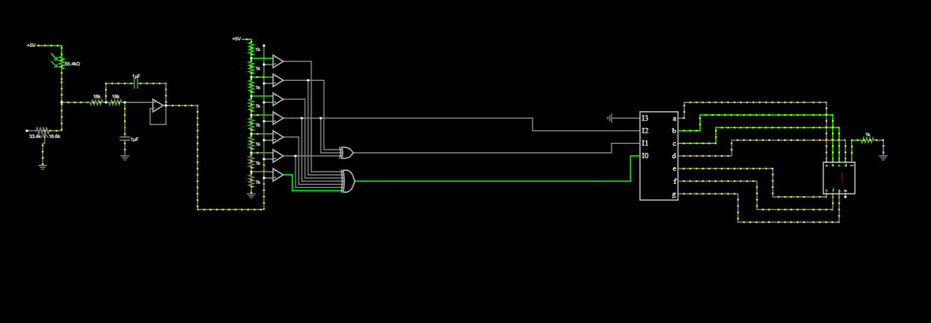

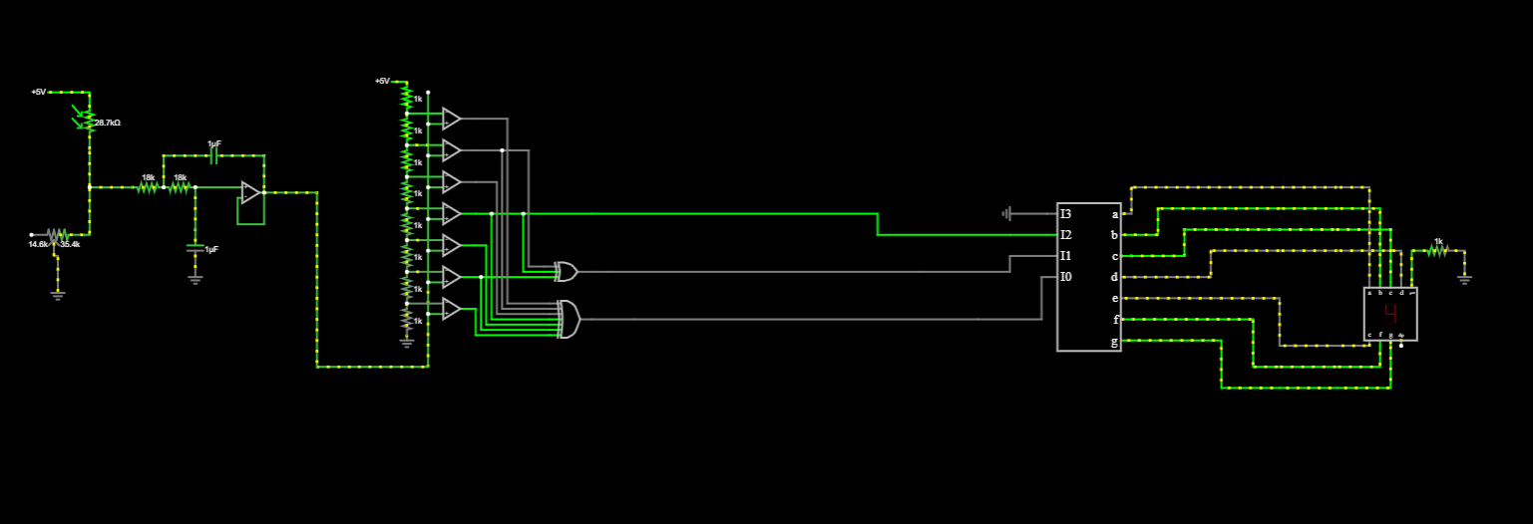

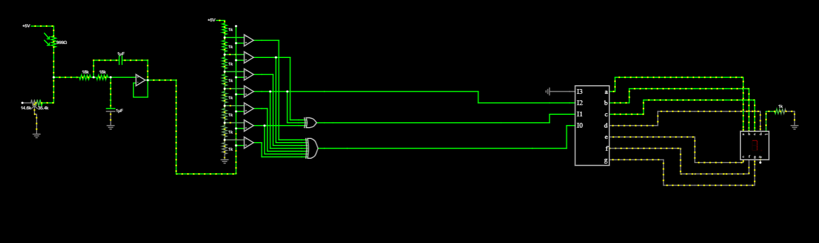

Key Design Decisions
- Eight levels (0–6) chosen for:
  - High readability
  - Low complexity
  - Minimal logic gate count
- Comparator ladder selected over ADC circuits because it:
  - Is simpler
  - Fits rule restrictions
  - Gives clean, predictable thresholds
- Gate-based decoder ensures full transparency and customizability of the display logic.

Outcome
- The system accurately converts light intensity into a 3-bit digital value.
- The 7-segment display updates instantly and clearly.
- Final display reliably shows values from 0 to 7 depending on ambient light.

TASK 3 – Light Stability Detection

Objective
Sudden changes in light can cause quick jumps in the reading. To avoid this, the system slows down the response. This prevents short-term light fluctuations from immediately changing the displayed value. The display should update only when the light remains steady for an adjustable time between 30–300 seconds.
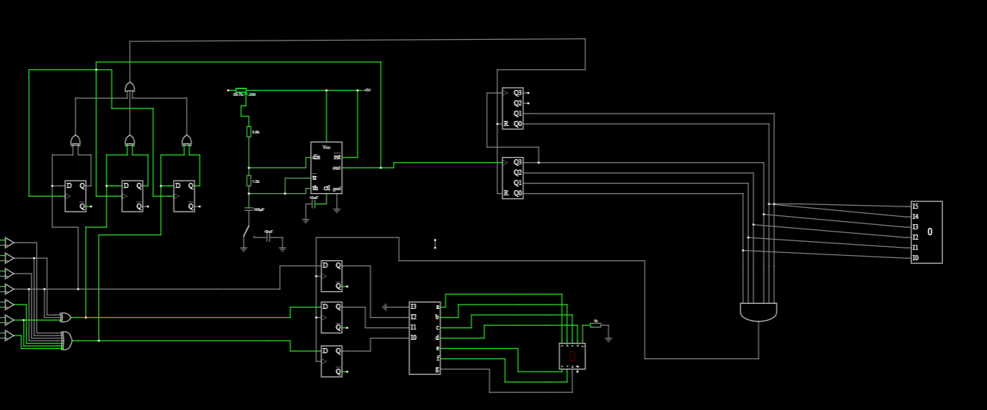
Flip-flops and Logic Gates
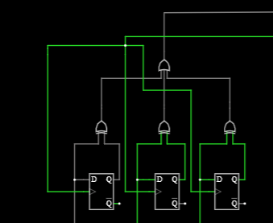
This block contains several flip-flops are wired together with XOR/OR gates in a specific configuration. Its main purpose is to hold the light-level value only when the input remains stable for a long enough period.
Why this is needed:
The LDR output can fluctuate rapidly due to sudden shadows, passing objects, noise, etc…If the system directly sent these rapid changes to the display, the number would jump or flicker constantly. So this part receives the 3-bit light level from the comparator block, when the light level changes, the flip-flops wait. The 555 timer measures how long the value stays unchanged. Only if the same value remains for the full stability time (30–300 seconds), the AND gates allow the value into the flip-flops then flip-flops update the output and the new stable value appears on the display.

555 Timer Block

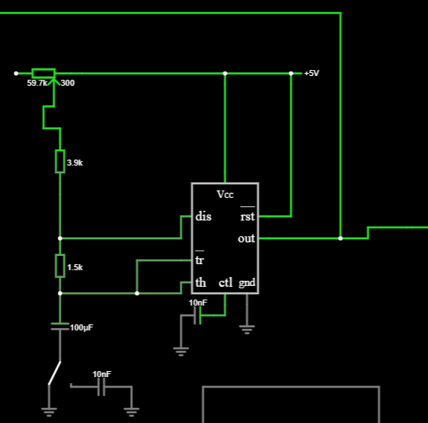
This provides the delay period (stability time) of 30–300 seconds. The output enables the flip-flops after the timer expires and works together with the flip-flops to avoid sudden jumps.This block contains a 555 timer IC, resistors and capacitors controlling timing and a switch or jumper.

This provides the delay period (stability time) of 30–300 seconds. The output enables the flip-flops after the timer expires and works together with the flip-flops to avoid sudden jumps.

This creates the feature update display only when light is stable long enough.
When a change is detected, the RC network sets a delay during which the 555 timer output stays HIGH. The falling edge of this pulse then clocks the D-flipflops, updating the display with the new data.
Component Selection:
T = T_{High} + T_{low}
We generate a pulse which has T$=\frac{30s}{64}$ = 0.46875s.
In Astable mode 555 timer configuration we use these formulas to calculate resistor values and capacitor values
T_{High} = 0.693 x (R₁+ R₂) x C
T_{low} = 0.693 x R₂ x C
First, we select C value from market. In our circuit we used 100µF for capacitor.
Then we selected our T_{low} as 0.10395 s.
From the above 2nd equation,we get R₂ =1.5kΩ.
Finally, T_{High} =0.3648 s and we get R₁ = 3.9kΩ from the 1st equation.

As you wish we can change the time between 30s-300s, so we used a potentiometer for that.

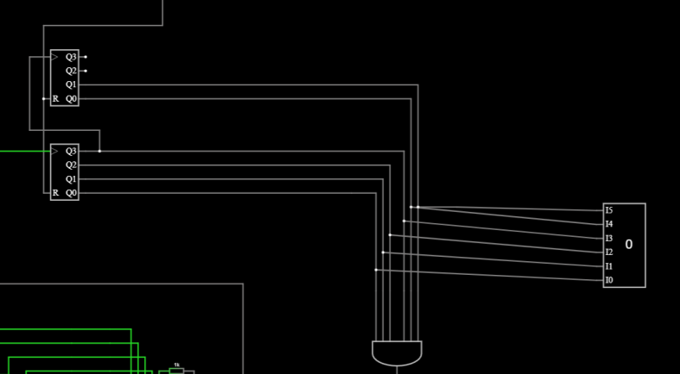
Digital counters: Count electrical pulses to measure the long adjustable time periods (30 to 900 seconds) required for the stability and averaging features. Here, R input is used to reset the count back to zero. We use 6 flip-flops thereby we count for 64 ($2^{6}$).

Here, if we want to get a time period of 30s, we get the 555 timer’s period;
$T=\frac{30s}{64}$ = 0.46875s
By increasing the no of flip-flops used accuracy can be increased.
AND Gate: This gate checks if the count has reached a specific maximum number. When the maximum count is reached, it signals that the required time period (e.g., 300 seconds) is over.
Display: This is to identify the count of 64.
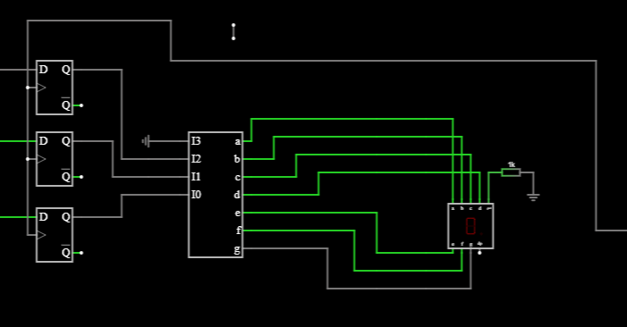
This block is a combination of D flip-flops, decoder and a 7-segment display.
D Flip-Flops: These blocks act as a latch. They temporarily hold the current, stable light intensity reading (a binary number like 000 to 111, representing levels 0 to 7).
Seven-Segment Decoder: It takes the 3-bit binary light level from the latches and converts it into the seven individual signals (a, b, c, d, e, f, g) needed to light up the correct parts of the display.
Seven-Segment Display: This is the output device. It lights up to show the final single-digit light intensity level (from "0" to "6") that the user sees.
Key Decisions
- RC timing was selected instead of counters to reduce complexity.
- Flip-flops ensure the output remains stable during the delay.
- Reset-on-change ensures full immunity to transient variations.

Outcome
The displayed brightness remains stable and only updates when the environment’s light level has truly changed. Short disturbances do not affect the display.

TASK 4 – Average Light Intensity Display

Objective
To calculate and display the average light intensity over a long sampling window (300–900 seconds) using a second 7-segment display, with a push-button for resetting the stored average.

Average part circuit
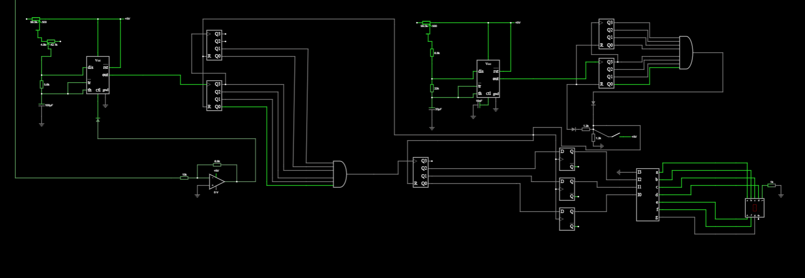
Strategy of the average light intensity finder
1. Principle of Operation To determine the average light intensity over a prolonged duration (300s – 900s), the system employs a Voltage-to-Frequency Conversion technique.
- Integration: A digital counter accumulates these pulses over the fixed measurement window (e.g., 900 seconds).
- Conclusion: The total number of pulses captured is the sum of the instantaneous intensities over time. Since the duration of the measurement window is fixed, the final accumulated count is directly proportional to the Average Light Intensity experienced by the sensor.
2. Signal Conditioning and Control (VCO Mechanics)
The measurement chain utilizes the 555 Timer in Astable mode, but with a modified control architecture:
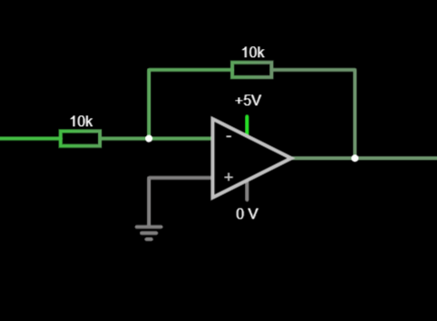
- Inversion Stage: The output from the analog filter is fed into a Unity-Gain Inverting Amplifier. This stage is necessary to invert the sensor logic before it reaches the timer.

- Control Pin Modulation: The inverted signal drives the Control Voltage (Pin 5) of the 555 Timer. This pin directly adjusts the internal upper switching threshold of the timer's comparator.

  - Lowering the Voltage: When a lower voltage is applied to Pin 5, the internal threshold is reduced below the standard 2/3 V_{cc} . The timing capacitor charges to this lower limit much faster, resulting in a shorter period and a higher frequency output.
  - Increasing the Voltage: Conversely, a higher voltage raises the threshold, forcing the capacitor to charge longer to trigger the discharge, resulting in a lower output frequency.

- System Response: Because the Inverting Amplifier converts "High Intensity" into "Low Voltage," the final behavior becomes: Higher Light Intensity Lower Control Voltage Higher Pulse Frequency.
3. Calculation of Average via Pulse Accumulation
The system relies on the mathematical relationship between signal frequency and total count over a fixed time.
- Dynamic Response: If the ambient light fluctuates during the measurement window, the 555 timer instantaneously modulates its pulse width and frequency to match the new intensity level.
- Integration: A digital counter accumulates these pulses over the fixed measurement window (e.g., 900 seconds).
- Conclusion (Assumptions): The total number of pulses captured is the sum of the instantaneous intensities over time. Since the duration of the measurement window is fixed, the final accumulated count is directly proportional to the Average Light Intensity experienced by the sensor.
$$Average Light Intensity α Accumulated Pulse count over a fixed time period$$

4.Pulse counting procedure.
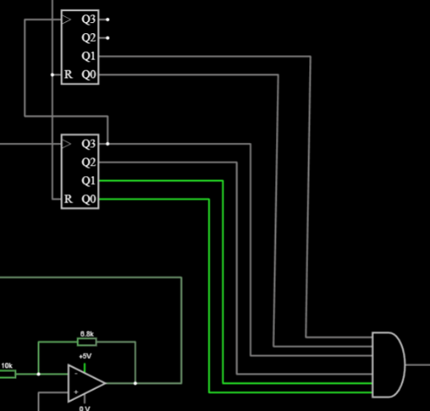
- Accumulate pulses using a 6 bit Counter : this counts the total number of pulses generated by the 555 timer.
- AND gate: After the 6-bit counter counts the 64, its output will high.
- 3-bit Counter: used to map the pulse count into 7 stages.

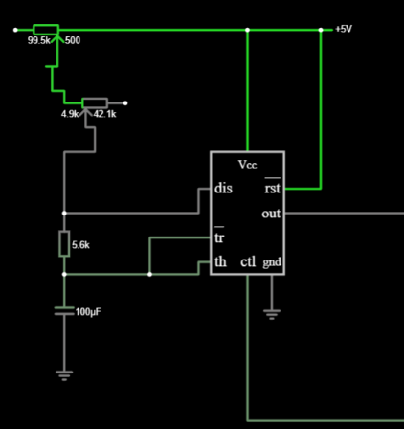
5.Pulse generator 555 timer configuration.
R1 = 100kΩ Dual gang potentiometer + 50 kΩ multi turn potentiometer
R2 = 5.8kΩ
C = 100µF
These values have taken assuming there is no control voltage at the control pin of the 555 timer and from the practical experiments.

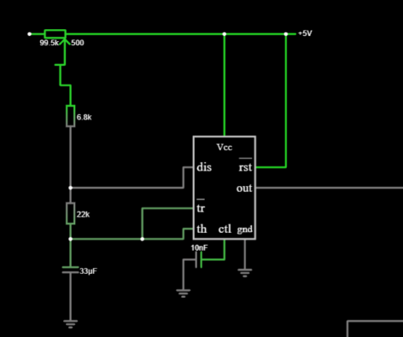
6.Timing (300-900 Sec) 555 timer.
This timer output fed into an 8 bit counter (for reset purposes)
$$T_{300}=\frac{300 sec}{256 }=1.18 Sec$$
$$T_{900}=\frac{900 Sec}{256}=3.516$$
According to T = 0.693 x (R1+2xR2)x C formular we choose the values to the R and C components
R1 = 100kΩ Dual gang potentiometer (the 2 timers of the average part shares a single potentiometer)+6.8kΩ
R2 = 22kΩ
C = 33µF
A critical design challenge arose from the requirement to make the averaging period adjustable between 300 and 900 seconds.
- The Problem: In a standard pulse-counting system, extending the measurement window from 300s to 900s (a 3 x increase) would naturally result in capturing 3x as many pulses for the same light intensity.
- The Error: This would cause the display to show an incorrect value (e.g., a light level of "7" would read as "7" at 300s, but "21" at 900s), destroying the system's calibration.
- The Solution:- Simultaneous Adjustment
To maintain a consistent "0-to-7" scale regardless of the user's selected time duration, a Dual-Gang Potentiometer (two variable resistors mechanically linked to a single shaft) was implemented to adjust both the Time and the Frequency simultaneously.

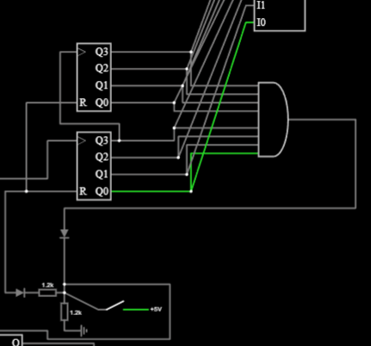
7.Resetting Part
After counting 256 counts from the 8-bit counter the AND gate output will go High and this trigger the resets of 8-bit counter itself,3-bit counter,6-bit counter, D flip flops. And also, there is a reset push button to initiate the average part of the circuit. The Diodes and resistors have added to ensure the reliability of the circuit.

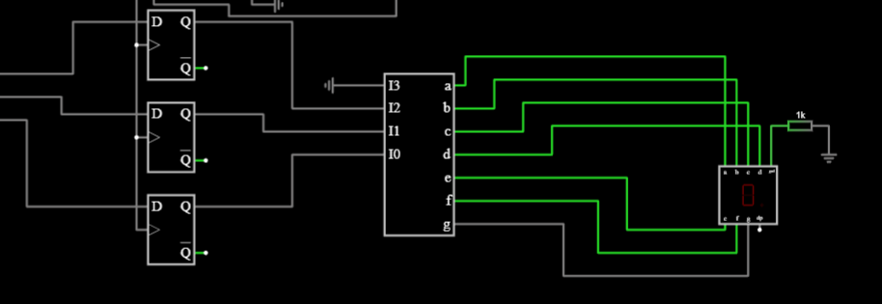
8.Displaying procedure

This procedure is exactly same as the stability circuit.

Assumptions – the pulse width is changing nearly linearly with the light intensity.

Outcome
The system shows smooth and stable average reading, providing a long-term view of lighting conditions. The feature operates independently of the main real-time display.

